Directions: Answer the questions below on a separate sheet of lined paper.

Introduction: The Magna Carta is the most celebrated source of traditional English regard for
individual rights and liberties. Signed in 1215, the Magna Carta was a contract or agreement between King John and the nobles who were vassals under his power. The document firmly established for the first time in English history that political rights were guaranteed and that not even the king was above the law. While it was initially written to safeguard only the feudal rights of the nobles and to limit the power of the king, over time the principles of Magna Carta were extended to protect liberties for English people of all classes, and provided the basis for the establishment of the English constitutional monarchy and parliamentary system.

Image of the Magna Carta
On the actual copy of the Magna Carta is the Royal Seal (which shows authenticity). 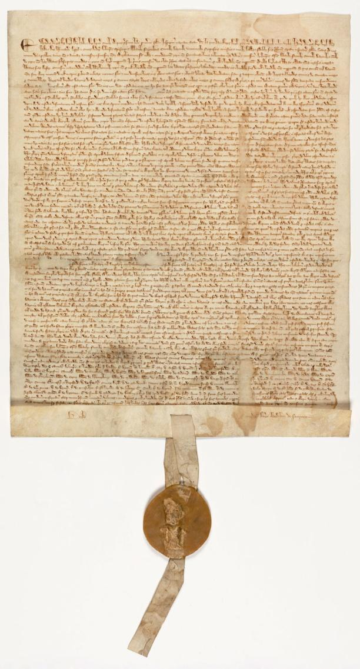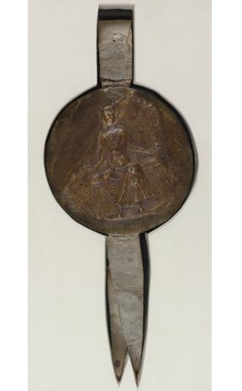
1. What do you think the significance is of the seal attached to the actual parchment
copy of the Magna Carta?

Translation of the Magna Carta
Go to
https://www.archives.gov/exhibits/featured-documents/magna-carta/translation.html and
answer the following questions.

Keep in mind that the document is written in what is known as the “royal third person”: the document’s statements are made by the king, but he always refers to himself in the plural sense (“we” instead of “I,” “our” instead of “my,” “us” instead of “me,” etc.).

2. According to article [1] the Magna Carta was “confirmed, for us and our Heirs forever.” Why do you think it was important to the nobility to have this principle included in the document?

3. Articles [2] through [8] deal with questions of inheritance. Why was the issue of inheritance of major concern to the nobles?

4. In articles [12] and [13], the document discusses assises, which were court proceedings led by traveling judges. The articles basically lay out formal procedures for conducting the assises. Why do you think the nobles considered this necessary?

5. What is the purpose of articles [19] through [21]?

6. Restate article [29] in your own words. What guarantees did it provide for any “freeman”?

7. Which article or articles of the Magna Carta do you still find significant today? Explain the reasons for your choice.

8. Place yourself in the role of one of the following types of people who lived in medieval times: peasant, noble, judge, sheriff, soldier, priest, king. From the point of view of the type of person you chose, write a letter (minimum ¾ page handwritten on lined paper) sharing their reaction to the signing of the Magna Carta from their point of view. Use evidence from the Magna Carta to support your position.

